Our Word Study List  - went  - all  - into  - get  - come  Word Family: Students should know how to read and write words with the _ent spelling pattern.  Examples: sent, bent | Mrs. Eberle’s Super Class News  News for the Week of September 4, 2017
Monday, September 4, 2017

- Labor Day – No school today!

Tuesday, September 5, 2017

- Wear tennis shoes today for P.E.
- Home practice packet

Wednesday, September 6, 2017

- Home practice packet

Upcoming Events
9/4 – Labor Day – No school
9/8 – Progress Reports
September Birthdays

Jane 9/8
Reece 9/25
Jack M. 9/29

Thursday, September 7, 2017

- Return library book
- Home practice packet
Friday, September 8, 2017

- Return home practice packet
- Have a great weekend!

*PLEASE SEE OTHER SIDE.
Special Classes  Monday: Art  Tuesday: P.E.,  Wednesday: Music, guidance  Thurs: Library  Friday: Computer Lab  Lunch: 12:30-1:00  Although it rarely happens, lunch times are subject to change due to delays, special activities, etc.  *********************Principal’s Club  Effort: Bentlee  Character: Jane  Achievement: Ryder  Student of the Week:  Austin  Congratulations!  We are proud of you! | Notes:  * We worked hard this week rotating through our stations independently while I pulled groups over to the reading table. It was great listening to everybody read and I think they enjoyed moving around the room. In math we took our first REAL math test and did our timed quiz over +2. Please look over the math CFA with your child and return it to school after it is signed. I am also sending home the +2 quiz, which does not need to be returned. If your child had difficulty with this, he/she will practice more and try again in a few days.  *REMINDER – No rush! * To help us feel safe and loved at school, we are creating a space in our classroom for family pictures. Students can bring in a picture (or more than one if they need to do that to show their whole family) and we will put it on our Friends and Family board. These do not need to be professional photographs! Anything you have is fine! Also, I would love to say these would be returned but they are being placed in a pretty high traffic area. A copy might be the way to go. Please send pictures by Friday, September 16. Thank you!  *Just a reminder that students are allowed to have water bottles for class. The pop-up tops work much better than the kinds with lids that have to be screwed on. When they have a water bottle, I do not have to have them go out of the classroom to get a drink.  *The lunchroom will be having a fun sports theme at lunch on September 15. They are sending home copies of blank jerseys that can be decorated at home and returned to school any time before that day. Students can copy a specific jersey or make up their own.  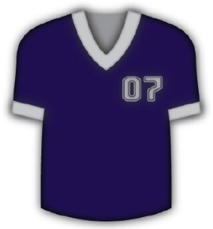
First Grade website:  www.fkefirstgrade.  weebly.com | “Learning Rocks!”

