Our Word Study List  - down  - want  - over  - where  - her  Word Family: Students should know how to read and write words with the _own spelling pattern.  Examples: brown, town | Mrs. Eberle’s Super Class News  News for the Week of September 25, 2017
Monday, September 25, 2017

- Home practice packet

Tuesday, September 26, 2017

- Wear tennis shoes today for P.E.
- Home practice packet

Wednesday, September 27, 2017

- Home practice packet
- Conference forms are due today

Upcoming Events
9/28 – Book Fair, dress in western attire (optional)
10/2 – Fall break begins!
10/16 – Welcome back to school!
11/3 – Zoo trip!
September Birthdays

Jane 9/8
Reece 9/25
Jack M. 9/29

Thursday, September 28, 2017

- We visit the Book Fair today! Wear your western clothes if you would like!
- Return library book
- Home practice packet
Friday, September 29, 2017

- Return home practice packet
- Have a great fall break!

*PLEASE SEE OTHER SIDE.
Special Classes  Monday: Art  Tuesday: P.E.,  Wednesday: Music, guidance  Thurs: Library  Friday: Computer Lab  Lunch: 12:30-1:00  Although it rarely happens, lunch times are subject to change due to delays, special activities, etc.  *********************Principal’s Club  Effort: AJ  Character: Aly  Achievement: Lexi  Student of the Week:  Sophia  Congratulations!  We are proud of you! | Notes:  * Busy, busy, busy! We worked on so many things this week in first grade! In reading we worked on identifying the actions and words of the characters in order to determine what type of person they are. We also starting working on recognizing the importance of the setting in a story. In writing we worked on writing stories with a beginning, middle, and end and then going back to add more details. In math we continued to really dig into these place value concepts. We have been able to use our manipulatives to play some games and work on our problem solving skills. We also learned about magnets last Friday for science, which everyone loved! This week during stations they used the information we learned and some magnet books to write facts.  *First grade will be having a field trip to the Louisville Zoo on Friday, November 4 and you are invited! This is our only field trip this year, and one of the only FKE trips that allows chaperones. We are hoping to have many volunteers sign up to go with us. You DO NOT need to let me know now if you can go. We are sending a note home right after fall break and that is when parents can sign up to attend. There is no limit on how many can go. The more the merrier!  *Our class will visit the book fair here at school on Thursday, September 28 from 1:35-2:15. You are welcome to come help your child shop or a volunteer will be available to assist them. Also, classes are asked to dress in western attire on the day of their book fair.  *We had a pirate come read to us for “Talk Like a Pirate Day” this week. Here we are looking tough!  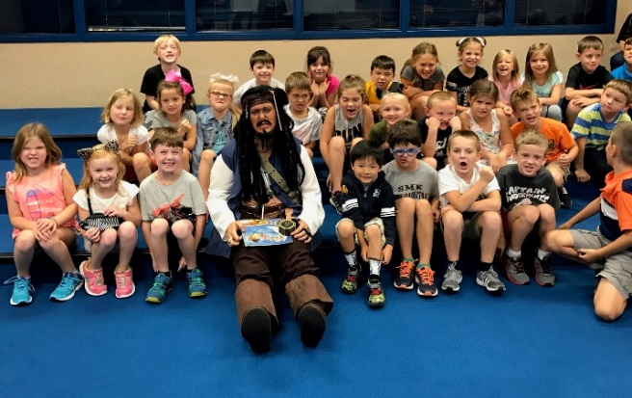
First Grade website:  www.fkefirstgrade.  weebly.com | “Learning Rocks!”

