Our Word Study List  1.oil  2.ate  3.could  4.should  5.would  Word Family: Students should know how to read and write words with the _oil spelling pattern.  Examples: boil, coil | Mrs. Eberle’s Super Class News  News for the Week of February 19, 2018
Monday, February 19, 2018

- Home practice packets

Tuesday, February 20, 2018

- Wear tennis shoes for PE today!
- Home practice packets

Wednesday, February 21, 2018

- Home practice packet

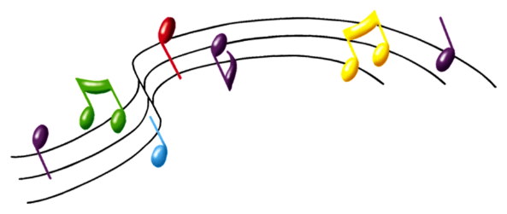
Upcoming Events
3/12 – Reading Rodeo 5:30-7:00
February
Birthdays

Ryder 2/9

Thursday, February 22, 2018

- Return your library book today!
- Home practice packet
Friday, February 23, 2018

- Return home practice and book bags today!
- Have a great weekend!

*PLEASE SEE OTHER SIDE.
Special Classes  Monday: Art  Tuesday: P.E.,  Wednesday: Music, guidance  Thurs: Library  Friday: Computer Lab  Lunch: 12:30-1:00  Although it rarely happens, lunch times are subject to change due to delays, special activities, etc.  *********************Principal’s Board  Effort: Loralei  Character: Austin  Achievement: Bella  Student of the Week:  Bentlee  Congratulations!  We are proud of you! | Notes:  *This week in reading we started working on fables and identifying the moral of the story. This can sometimes be tricky! In writing we continued to work on publishing and editing our persuasive pieces. In math we worked on plane and solid shapes and had a lot of fun using our snack items to practice sorting by various attributes and creating 2D and 3D shapes. Thank you to everyone who sent in items! We also played a Guess Who shape game and searched or room for plane and solid shapes.  *We had a great time with our science lesson this week as we experimented with candy hearts in various liquids. We made predictions and then conducted our experiment to see if our results were proven true or false.  *Congratulations to everyone who participated in the science fair this year. I know that is a lot of work! We learned a lot and are proud of your hard work!  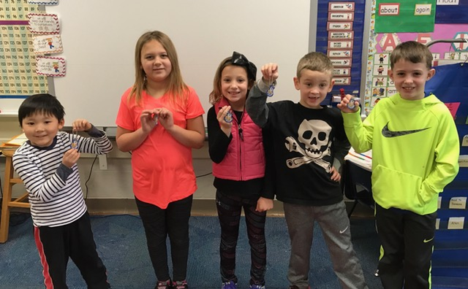  *Don’t forget that our Reading Rodeo will be Monday, March 12 from 5:30 to 7:00. Stop in anytime that night for some reading fun!  *Thank you for returning the book baggies! Having them all in by Friday allows us to move them on to the next classmate.
First Grade website:  www.fkefirstgrade.  weebly.com | “Learning Rocks!”

