Our Word Study List  1.ride  2.from  3.one  4.two  5.help | Mrs. Eberle’s Super Class News  News for the Week of December 4, 2017
Monday, December 4, 2017

- Home practice packet

Tuesday, December 5, 2017

- Wear tennis shoes for P.E. today!
- Home practice packet

Wednesday, December 6, 2017

- Home practice packet

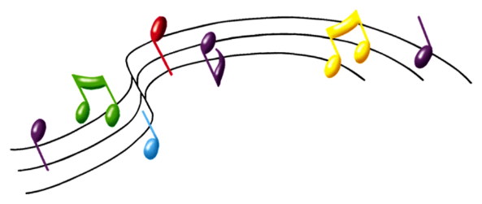
Upcoming Events

December
Birthdays

Sophia 12/3
Bentlee 12/9

Thursday, December 7, 2017

- Return your library book today!
- Home practice packet
Friday, December 8, 2017

- Home practice packets due
- Have a great weekend!

*PLEASE SEE OTHER SIDE.
Special Classes  Monday: Art  Tuesday: P.E.,  Wednesday: Music, guidance  Thurs: Library  Friday: Computer Lab  Lunch: 12:30-1:00  Although it rarely happens, lunch times are subject to change due to delays, special activities, etc.  *********************Principal’s Board  Effort: Tessa  Character: Lilly  Achievement: Jack S.  Student of the Week:  Reece  Congratulations!  We are proud of you! | Notes:  *We have been hard at work this week during reading as we ask and answer questions about our stories and derive meanings for words using context clues. During writing we finished our owl books and started a new nonfiction piece. In math we have worked on our problem solving skills with some more story problems and kept up our hard work on adding ten to a number. We also worked on fact families, which started out a bit challenging. By the second day it seemed like things were clicking! These skills are very important to future math learning, so we want to make sure everyone really knows them! We also did some fun candy cane science on Friday to kick off the month of December.  *Just a reminder that students may have a water bottle in class. It is great if they can bring one since we do not a water fountain in our room. Students who do not currently have one have to go out in the hall to get a drink.  *REMINDER – Secret Angel gifts are due by Monday, December 4. Thank you!  *Progress reports are coming home today. Please take a look and sign and return by December 8. Also, we will do our next reading assessments before Christmas break and those results will be on the January report card. Please let me know if you have any questions.  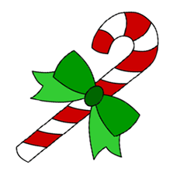
First Grade website:  www.fkefirstgrade.  weebly.com | “Learning Rocks!”

