Our Word Study List  No new words for our short week! | Mrs. Eberle’s Super Class News  News for the Week of November 20, 2017
Monday, November 20, 2017

- Bring in Project 3 from packet-Thanksgiving Activity Sheet

Tuesday, November 21, 2017

- Wear tennis shoes for P.E. today!
- Home practice packet

Wednesday, November 22, 2017

- No school - Enjoy your day off!

Upcoming Events

November
Birthdays

Cal 11/11
Lexi 11/12

Thursday, November 23, 2017

- Happy Thanksgiving!
Friday, November 24, 2017

- No school - Do something fun today!
- Have a great weekend!

*PLEASE SEE OTHER SIDE.
Special Classes  Monday: Art  Tuesday: P.E.,  Wednesday: Music, guidance  Thurs: Library  Friday: Computer Lab  Lunch: 12:30-1:00  Although it rarely happens, lunch times are subject to change due to delays, special activities, etc.  *********************Principal’s Board  Effort: Jack M.  Character: Reece  Achievement: Remi  Student of the Week:  No one next week!  Congratulations!  We are proud of you! | Notes:  * We loved comparing and contrasting the old and new items that they brought in on Friday. It is funny every year to hear them talk about how people used these odd things called “cassettes” or phones with cords WAAAYYYY back in the old days. You know, the eighties.  *Please send in Project 3, the paper about Thanksgiving activities, on Monday, November 20. We will use these to complete an activity in class that should make a nice keepsake.  * In reading this week we have been working on identifying the main idea and details in stories we read. During Writing Workshop we have continued to work on our informational writing book about owls. These are coming along very well! In math we started working on story problems using addition and subtraction. Next week they will have to use the given information to determine how to solve the problem more independently. We also had a fun presentation called “Henry the Hand” from a group of local volunteers. They talked to us about handwashing and other healthy habits.  *No new word study words or home practice due to the short week next week!  *Have a wonderful Thanksgiving! I am thankful for this class!  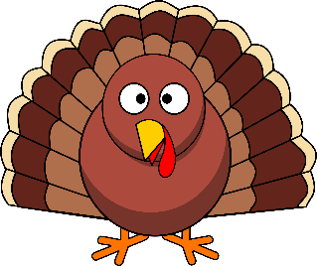
First Grade website:  www.fkefirstgrade.  weebly.com | “Learning Rocks!”

